- Home position.

When you press connect. It will set the default home position.
To change home position. Adjust your robotic arm to a desired position and press connect.
When you press Home. It will go back to home.

- Speed.
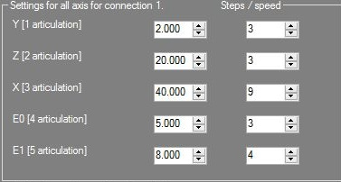
Left hand is motor steps. Right hand is motor speed.
The speed setting is only true when you manually move the robotic arm.
When you press save. It will save the recorded gcode at the default path "C:\Program Files (x86)\Quantum Software\RoboticArm\" as text file below:

1 G01 X560 Y90 Z40 E0 H-32 F0.00046
wait:3
1 G01 X0.0000 Y0.0000 Z0.0000 E0.0000 H0.0000 F0.000461

1 means it will use connection 1.
G01 is absolute mode
F0.00046 is the default speed for all motor.
There is only one speed value as all motors will move at the same time when you play back the recorded gcode in the software. To slow down, you can edit the F value to F0.000460

